NAME: SHAIK MOHAMMAD IRFAN
REG NO :192472190

SIMATS ENGINEERING
ASSESSMENT TOOL 3 - CASE STUDY
Course Code: ITA14 | Course Name: Ethical Hacking
Course Outcome: CO4 - Implement network security testing methods by performing web server attacks, analyzing web application vulnerabilities, and assessing wireless network security using Kali Linux. (BT4, BT5)
Assessment Tool Weightage: 35% | Questions: 5 | Total Marks: 100
Code of Conduct
I ______________________________________________ (Name / Reg No) certify that this submission is my original work and that I have adhered to the guidelines specified for this assessment. I understand that any violation of academic integrity rules will result in disciplinary action.
Signature of the student: ___________________________

Case Study 1: Security Assessment of a Compromised E-Commerce Web Server

1. Introduction / Case Background
A mid-sized e-commerce company runs its customer-facing storefront on an Apache web server hosted on a Linux platform. Customers began reporting unauthorized transactions and abnormal account activity, and a review of server logs by the IT team surfaced repeated attempts to browse hidden directories and inject malicious script payloads through form fields. Two structural weaknesses made the environment attractive to an attacker: the Apache installation was running an outdated version with publicly known CVEs, and there was no Web Application Firewall (WAF) in front of the application to filter malicious traffic before it reached the server.
As the cybersecurity analyst assigned to this incident, the objective is to reconstruct how the compromise likely happened, validate the exposure in a controlled test environment using Kali Linux tooling, and design a layered defense so that hidden-directory discovery, injection, and version-based exploitation can no longer be chained together into account takeover and fraudulent transactions.
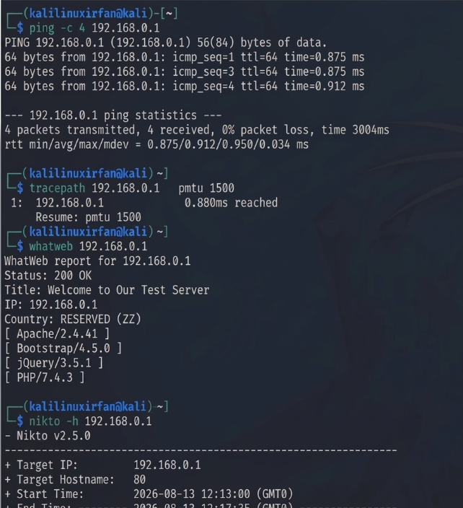

2. Attack Scenario
The presenting symptoms are unauthorized transactions and abnormal account activity, but the log evidence points to a pre-fraud reconnaissance-and-injection phase: directory enumeration requests (e.g. probing for /admin, /backup, /.git, /config) mixed with payloads aimed at input fields. This pattern is consistent with an attacker first mapping the unpublished attack surface of the site, then using that map to locate an entry point - a forgotten admin panel, a backup file exposing credentials, or a form vulnerable to injected script - and finally riding an outdated Apache/application-stack vulnerability to escalate from simple script injection to session hijacking or direct manipulation of order/payment data.
Because no WAF was present, none of these probing requests were filtered, rate-limited, or flagged before they reached the application, which explains why the activity was only noticed after real financial harm (unauthorized transactions) rather than being blocked at the perimeter.

3. Attack Vectors / Vulnerabilities
Three overlapping categories of weakness were exploited:
- Outdated Apache/software stack - an unpatched Apache version (and likely an outdated PHP/CMS layer behind it) exposes known CVEs with public exploit code, letting an attacker fingerprint the exact version and pull a matching exploit rather than developing one from scratch.
- Hidden/unlinked directory exposure - directories such as backup folders, staging copies, or version-control artifacts (.git, .env) that are reachable but not linked from the UI, often left behind by developers and forgotten.
- Input validation failures - form fields that accept and reflect or store attacker-supplied script (indicative of stored/reflected Cross-Site Scripting) and possibly a lack of parameterized queries permitting SQL injection into transaction or account-lookup logic.
- Absence of a WAF - removes the compensating control that would normally detect signature-based attack traffic (directory brute-force, script tags, SQL meta-characters) even while patching is pending.

4. Reconnaissance
Reconnaissance in the controlled assessment mirrors what the attacker likely did, but performed with authorization against a staging/replica environment:
- whois and dig/nslookup to map DNS records, mail exchangers, and any subdomains that widen the attack surface.
- Nmap (nmap -sV -p- <target>) to fingerprint the Apache version, open ports, and any exposed management services (SSH, database ports left open).
- WhatWeb / Wappalyzer-style fingerprinting and nikto -h <target> to identify the web stack (CMS, PHP version, Apache modules) and flag known misconfigurations.
- Gobuster or dirb/dirbuster (gobuster dir -u <target> -w wordlist) for directory and file brute-forcing to reveal exactly the kind of hidden paths (/admin, /backup, /.git) referenced in the logs.
- theHarvester for OSINT on employee emails/subdomains that could support a complementary phishing angle.

5. Scanning & Analysis
Once the surface is mapped, vulnerability scanning narrows down exploitable weaknesses:
- Nikto for automated web server misconfiguration and outdated-component scanning, cross-referenced against CVE databases for the fingerprinted Apache version.
- OpenVAS / Nessus (where licensed) for a broader authenticated vulnerability scan of the host OS and services.
- Burp Suite (Spider/Crawler + Scanner) to map the application's input surface (every form, parameter, and cookie) and passively flag reflected/stored XSS candidates.
- Manual review of any exposed .git or backup archive discovered during recon, since these frequently leak database credentials or source code that shortcuts further exploitation.

6. Controlled Validation / Exploitation Methodology
Exploitation is performed only in an isolated, authorized test copy of the application, never against production data, and every step is logged for the report:
- Confirm the outdated Apache/CMS version against searchsploit or the CVE feed, and, where safe, validate (not weaponize) using a proof-of-concept from Metasploit's module search against the lab instance to demonstrate reachability rather than to cause impact.
- Manually verify each hidden path found by Gobuster to confirm it is reachable without authentication and note what it exposes (config values, credentials, admin functionality).
- Submit controlled XSS test payloads (e.g. a harmless alert marker) into the flagged input fields to confirm the payload is stored/reflected without sanitization, without inserting anything intended to run against real users.
- Document each finding with request/response evidence rather than pushing exploitation into privilege escalation on shared infrastructure.

7. Impact Analysis (CIA Triad)
Mapped to the CIA triad:
- Confidentiality - exposed backup/config files and successful injection can leak customer PII, session tokens, and payment-adjacent data.
- Integrity - script injection and possible SQL injection allow attackers to alter order records, prices, or account balances, matching the reported unauthorized transactions.
- Availability - while not the primary symptom here, an attacker with this level of access could disrupt checkout flows or delete records, and version-based exploits can crash the Apache process outright.

8. Root Cause
The incident traces back to weak patch management (outdated Apache left unpatched despite known CVEs), poor deployment hygiene (backup and version-control artifacts left reachable in production), and no input-handling discipline in the application layer, compounded by the absence of a WAF that could have caught the enumeration and injection traffic even while the underlying issues were being fixed.

9. Security Recommendations / Mitigation
- Patch and version management: move Apache and all supporting components to a supported, patched release, and put automated patch-cadence monitoring in place.
- Server hardening: disable directory listing, remove or relocate backup/version-control artifacts out of the web root, restrict file permissions, and disable unused Apache modules.
- Secure coding practices: enforce parameterized queries/ORM usage against SQL injection, apply context-aware output encoding against XSS, and validate all input server-side (never trust client-side validation alone).
- Deploy a Web Application Firewall (e.g. ModSecurity with the OWASP Core Rule Set) to catch directory brute-forcing, script-tag payloads, and SQL meta-characters at the perimeter.
- Network-level protections: rate-limiting/IP reputation filtering, network segmentation between the web tier and the database, and centralized logging with alerting on repeated 404/403 probing patterns.
- Periodic penetration testing and automated vulnerability scanning as part of the release cycle, not just after an incident.

10. Conclusion
This incident illustrates how individually moderate weaknesses - an unpatched web server, a few forgotten files, and unsanitized inputs - combine into a serious breach once no compensating control (a WAF) exists to catch the reconnaissance phase. A layered response that pairs patching and secure coding with perimeter and network controls closes both the immediate exposure and the process gap that allowed it to go undetected.

11. References
- OWASP Foundation, "OWASP Top 10:2021 - The Ten Most Critical Web Application Security Risks," owasp.org, 2021.
- NIST, "SP 800-115: Technical Guide to Information Security Testing and Assessment," National Institute of Standards and Technology, 2008.
- Offensive Security, "Kali Linux Official Documentation," kali.org/docs, accessed 2026.
- OWASP Foundation, "OWASP Testing Guide v4.2," owasp.org, accessed 2026.
- Apache Software Foundation, "Apache HTTP Server Security Reports," httpd.apache.org/security, accessed 2026.
- PortSwigger, "Web Security Academy - Directory Traversal and Information Disclosure," portswigger.net/web-security, accessed 2026.

Case Study 2: SQL Injection and XSS Audit of a Financial Services Web Application

1. Introduction / Case Background
A financial services web application supports user login, account viewing, and transaction execution. A penetration test found the application vulnerable to both SQL Injection and Cross-Site Scripting (XSS): verbose error messages leak database structure, and user-supplied input is not sanitized before use in queries or before being rendered back to other users. This combination lets an attacker both extract sensitive customer data directly from the database and plant scripts that execute in other users' browsers.
As the analyst performing the security audit, the goal is to demonstrate exactly how these two classes of vulnerability can be exploited in this context, validate them methodically using Burp Suite and SQLmap, and translate the findings into concrete, prioritized remediation for a system handling financial data.
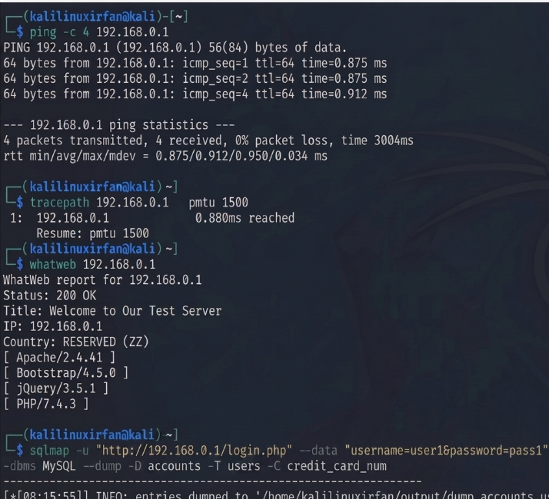

2. Attack Scenario
An attacker interacting with the login or account-lookup forms notices that malformed input (e.g. a stray quote character) returns a database error revealing table or column names - a classic sign of unsanitized input reaching a SQL query directly. This is a foothold for boolean-based or error-based SQL injection to enumerate the schema and extract customer records, including any exposed authentication data. Separately, the attacker finds an input field (e.g. a transaction memo or profile field) whose content is echoed back to other users without encoding, allowing a script payload to be planted and executed whenever another user - potentially with higher privileges - views that page (stored XSS), or reflected instantly via a crafted link (reflected XSS).

3. Attack Vectors / Vulnerabilities
- Unsanitized input reaching SQL queries (no parameterization/prepared statements), enabling SQL Injection across login, search, or filter parameters.
- Verbose error handling that returns raw database errors to the client, giving the attacker schema information for free (information disclosure aiding SQLi).
- Missing/incorrect output encoding on user-supplied content that is rendered back to other users, enabling stored and reflected XSS.
- Likely weak session handling (session ID exposure or lack of HttpOnly/Secure cookie flags) that turns a successful XSS into full session hijacking rather than a cosmetic issue.

4. Reconnaissance
Recon focuses on mapping every input point rather than the network layer, since the vulnerabilities are application-level:
- Burp Suite Proxy to intercept and log every request the application makes, building a full map of parameters (URL, form, cookie, header) across login, account, and transaction flows.
- Burp's Site Map / Spider (or a controlled crawl) to catalogue every page and endpoint, including any that require authentication.
- Manual walkthrough of the app noting which fields produce verbose error output when fed unexpected characters, and which fields' content is later displayed elsewhere (candidates for stored XSS).

5. Scanning & Analysis
- Burp Suite Scanner (active scan) run against the mapped endpoints to get an initial automated signal on injection and XSS candidates, cross-checked manually to remove false positives.
- Manual boundary testing: submitting a single quote, comment sequences, and boolean payloads (' OR '1'='1) into each parameter and observing response differences (error text, timing, content length) to confirm SQL injection.
- SQLmap (sqlmap -u "<url>" --data="<params>" --dbs) run against the confirmed injectable parameter(s) in the lab copy to enumerate databases, tables, and, only as far as needed to prove impact, sample column data.
- Burp Suite's XSS-specific checks plus manual payload variants (breaking out of different contexts: attribute, script, HTML body) to confirm which encoding gaps exist.

6. Controlled Validation / Exploitation Methodology
All validation is performed against a non-production/test instance with sanitized data, and payloads are chosen to prove impact without causing harm:
- SQL injection: use SQLmap's --dbs, --tables, and --dump options in a staged manner (schema first, then a small, non-sensitive sample) to demonstrate that customer records are reachable, documenting each command and result rather than exfiltrating full datasets.
- XSS: insert a benign, clearly-marked test script into the vulnerable field and confirm it executes when the page is viewed by a second test account, demonstrating that the same technique could hijack a live session (e.g. read document.cookie) without actually doing so against real users.
- Where session cookies lack HttpOnly, note this explicitly as the mechanism that would let a real XSS payload steal session tokens and pivot into account takeover, tying the two vulnerabilities together into a realistic attack chain.

7. Impact Analysis (CIA Triad)
- Confidentiality - SQL injection directly threatens customer PII and financial data; XSS-enabled session theft extends this to full account access.
- Integrity - an attacker with database write access via SQLi, or a hijacked session via XSS, can alter account balances or initiate unauthorized transactions.
- Availability - destructive SQL statements (if the injection point allows stacked queries) could corrupt or drop tables, and malicious scripts could be used to degrade the client-side experience or trigger further compromise (e.g. malware delivery).

8. Root Cause
The underlying cause is a lack of secure development discipline at two layers: database access built on string-concatenated queries instead of parameterized statements, and output rendering that trusts user input instead of encoding it for its context. Verbose error messages compound this by handing the attacker the schema information needed to exploit the SQLi efficiently.

9. Security Recommendations / Mitigation
- Input validation: enforce strict server-side allow-listing/type checking on every parameter, in addition to client-side checks.
- Parameterized queries / ORM: eliminate string concatenation in SQL statements across the codebase; treat any remaining dynamic SQL as a flagged exception requiring review.
- Output encoding: apply context-aware encoding (HTML, attribute, JS, URL) wherever user input is rendered, and adopt a templating framework that encodes by default.
- Secure session handling: set HttpOnly, Secure, and SameSite flags on session cookies, rotate session IDs on privilege change, and enforce short idle timeouts for a financial application.
- Generic error handling: replace verbose database errors with generic client-facing messages while logging full detail server-side only.
- Security controls: introduce a WAF tuned for SQLi/XSS signatures, Content-Security-Policy headers to blunt the impact of any XSS that slips through, and periodic re-testing with Burp Suite/SQLmap as part of the release pipeline.

10. Conclusion
SQL injection and XSS are individually well-understood, but in this application they compound each other: SQLi threatens the data at rest while XSS threatens the sessions that protect it. Because the target is a financial system, remediation should prioritize parameterized queries and cookie hardening first, since these two changes close the highest-impact paths to account takeover and data exfiltration.

11. References
- OWASP Foundation, "OWASP Top 10:2021 - The Ten Most Critical Web Application Security Risks," owasp.org, 2021.
- NIST, "SP 800-115: Technical Guide to Information Security Testing and Assessment," National Institute of Standards and Technology, 2008.
- Offensive Security, "Kali Linux Official Documentation," kali.org/docs, accessed 2026.
- PortSwigger, "Burp Suite Documentation - Web Vulnerability Scanner," portswigger.net/burp/documentation, accessed 2026.
- sqlmap developers, "sqlmap Usage Documentation," sqlmap.org, accessed 2026.
- OWASP Foundation, "OWASP Cheat Sheet Series - SQL Injection Prevention and XSS Prevention," cheatsheetseries.owasp.org, accessed 2026.

Case Study 3: Rogue Access Point (Evil Twin) Attack on a Corporate WPA2-PSK Network

1. Introduction / Case Background
A corporate office provides employee Wi-Fi secured with WPA2-PSK. Employees began seeing unusual login prompts and experiencing degraded network performance, and investigation revealed a rogue access point broadcasting the same SSID as the official network - an Evil Twin - which was used to capture credentials and conduct man-in-the-middle interception.
As the analyst investigating the breach, the task is to reconstruct how the Evil Twin was set up and used, show how Kali Linux tools such as Aircrack-ng and Wireshark can detect and analyze this class of attack, identify what let it succeed against a WPA2-PSK network, and propose countermeasures suited to a corporate environment.
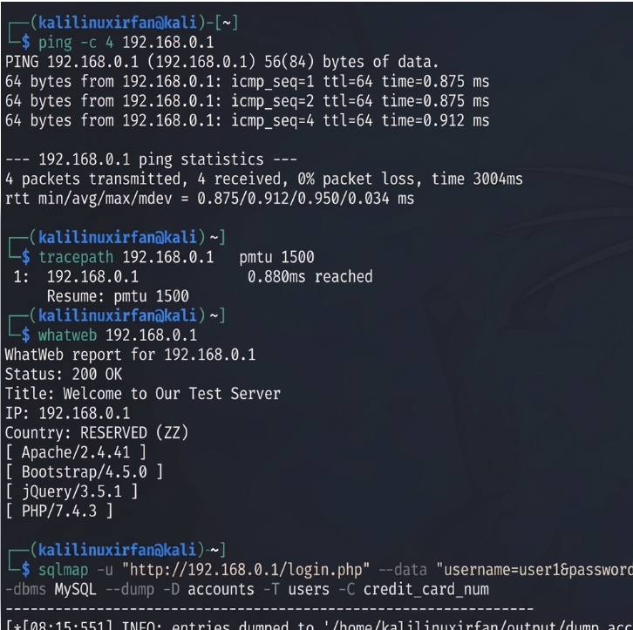

2. Attack Scenario
WPA2-PSK provides no mechanism for a client device to verify that an access point broadcasting a given SSID is the legitimate one - authentication is shared-secret-based, not AP-identity-based. An attacker within radio range set up a second access point with the same SSID (and often a stronger signal or the same/spoofed BSSID pattern), so employee devices that auto-connect to remembered networks associated to the rogue AP instead of the real one. Once employees are connected, the attacker sits in the traffic path: unencrypted or captive-portal-style login prompts can be presented to harvest credentials directly, while all other traffic passing through the rogue AP is available for man-in-the-middle inspection or manipulation. The reported 'unusual login prompts' are most consistent with a captive-portal credential-harvesting page injected by the rogue AP, and the 'slow network performance' with traffic being relayed through the attacker's device rather than the legitimate access point.

3. Attack Vectors / Vulnerabilities
- No AP-identity verification in WPA2-PSK - any device broadcasting the correct SSID (and matching pre-shared key requirements) can be trusted by client devices with auto-connect enabled.
- Shared pre-shared key model - because the same passphrase authenticates every user, a leaked or guessed PSK (or a de-authenticated client forced to reconnect) gives an attacker everything needed to also run a convincing twin.
- Deauthentication frames are unauthenticated in 802.11 management frames (absent 802.11w/PMF), letting an attacker forcibly disconnect clients from the real AP so they reconnect to the rogue one.
- Lack of wireless intrusion detection - no monitoring was in place to flag a second AP broadcasting the corporate SSID.

4. Reconnaissance
To understand and reproduce the attack in a controlled lab, reconnaissance covers the wireless environment itself:
- airmon-ng to put a compatible wireless adapter into monitor mode.
- airodump-ng to survey nearby SSIDs/BSSIDs, channels, and signal strength, which is exactly how a defender would spot a second AP broadcasting the corporate SSID (a duplicate SSID with a different BSSID and possibly different channel/signal strength is the tell-tale sign).
- Kismet as a complementary wireless IDS-style scanner for longer-duration monitoring and rogue-AP alerting.

5. Scanning & Analysis
- airodump-ng --bssid <target> -c <channel> -w capture to focus capture on the suspect AP and log associated client MAC addresses, confirming whether client devices are indeed associating with the unexpected BSSID.
- Wireshark analysis of the captured traffic (opening the .cap file) to inspect 802.11 management frames for deauthentication bursts, and to identify any HTTP-level credential submissions if the rogue AP used an unencrypted captive portal.
- Comparing beacon frame details (BSSID, channel, encryption type, vendor OUI) between the legitimate and rogue AP to build the evidence trail for the incident report.

6. Controlled Validation / Exploitation Methodology
To validate the vulnerability responsibly, the Evil Twin is reproduced only in an isolated lab against test devices, never against live employee hardware:
- airbase-ng -e "<SSID>" -c <channel> mon0 to stand up a rogue AP broadcasting the same SSID as the lab's legitimate network.
- aireplay-ng --deauth to send deauthentication frames to a lab test client, forcing it to disconnect from the legitimate AP and demonstrating how easily this pushes the client toward reconnecting to whichever AP responds - in this case, the rogue one.
- Wireshark running throughout to capture and confirm the client's reassociation with the rogue AP and to show, in a controlled way, what traffic becomes visible to the attacker once that happens.
- Documenting each step (commands, timestamps, captured frames) so the finding is reproducible evidence, not just an assertion.

7. Impact Analysis (CIA Triad)
- Confidentiality - credentials submitted to the rogue captive portal, and any unencrypted traffic relayed through it, are directly exposed to the attacker.
- Integrity - a man-in-the-middle position lets the attacker modify traffic in transit (e.g. injecting malicious content into unencrypted HTTP responses).
- Availability - repeated deauthentication both enables the attack and independently degrades network availability for legitimate users, matching the reported performance complaints.

8. Root Cause
The root cause is architectural: WPA2-PSK combined with unprotected management frames gives clients no reliable way to distinguish the real AP from an impostor, and the absence of wireless monitoring meant the rogue AP could operate for a period before anyone noticed the duplicate SSID.

9. Security Recommendations / Mitigation
- Move to WPA2/WPA3-Enterprise (802.1X) authentication so each user has individual credentials tied to a RADIUS server, removing the shared-secret weakness a twin can exploit.
- Enable 802.11w (Protected Management Frames) so deauthentication frames are authenticated and can't be trivially spoofed.
- Deploy a Wireless Intrusion Detection/Prevention System (WIDS/WIPS) to continuously monitor for duplicate SSIDs, rogue BSSIDs, and abnormal deauth volume, with automated alerting.
- Disable client auto-connect to open or ambiguous networks, and push certificate-based network profiles via MDM so devices only trust the legitimate AP.
- User awareness training on recognizing unexpected login prompts and reporting connectivity anomalies promptly.
- Periodic wireless site surveys (using Aircrack-ng suite/Kismet) as part of routine security operations, not only after an incident.

10. Conclusion
The Evil Twin attack succeeded because WPA2-PSK offers no AP-identity assurance and management frames were unprotected, and it went undetected because there was no wireless monitoring layer. Moving to enterprise authentication, enabling management-frame protection, and adding continuous wireless monitoring together close both the exploitation path and the detection gap.

11. References
- OWASP Foundation, "OWASP Top 10:2021 - The Ten Most Critical Web Application Security Risks," owasp.org, 2021.
- NIST, "SP 800-115: Technical Guide to Information Security Testing and Assessment," National Institute of Standards and Technology, 2008.
- Offensive Security, "Kali Linux Official Documentation," kali.org/docs, accessed 2026.
- Aircrack-ng developers, "Aircrack-ng Documentation," aircrack-ng.org/documentation.html, accessed 2026.
- Wireshark Foundation, "Wireshark User's Guide," wireshark.org/docs, accessed 2026.
- Wi-Fi Alliance, "WPA3 Specification and Security Overview," wi-fi.org, accessed 2026.

Case Study 4: Full Attack Chain - Wireless Compromise Leading to Web Application Privilege Escalation

1. Introduction / Case Background
An organization's internal employee management system is a web application reachable over the office Wi-Fi network. The wireless network uses weak passwords, and the web application itself lacks proper authentication and session management. An attacker who gains Wi-Fi access performs reconnaissance and then exploits the web application to escalate privileges and reach confidential employee data.
This assessment traces the full attack chain end to end - wireless compromise, network reconnaissance, web application exploitation, and privilege escalation - and proposes a defense-in-depth framework spanning both the wireless and application layers, since either layer alone would only close part of the path.
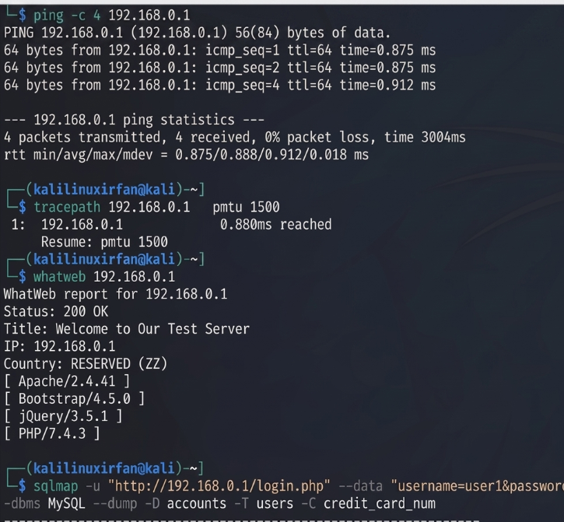

2. Attack Scenario
The chain begins at the wireless layer: a weak (short, dictionary-based, or default) Wi-Fi password can be recovered through an offline handshake-capture-and-crack attack, giving the attacker a foothold on the internal network without ever needing to be inside the building's wired infrastructure. Once on the network, the attacker can reach the internal employee management application directly - something normally shielded from the public internet, but here reachable simply by being on the same Wi-Fi segment. Weak authentication (e.g. predictable session tokens, no account lockout, or default credentials) lets the attacker log in or brute-force access, and weak session management (long-lived or non-invalidated sessions, missing authorization checks on sensitive endpoints) then allows the attacker to escalate from a low-privilege or guest-level foothold to viewing or modifying confidential employee records - salary, personal data, or HR records.

3. Attack Vectors / Vulnerabilities
- Weak Wi-Fi passphrase, vulnerable to offline dictionary/brute-force cracking once a WPA/WPA2 handshake is captured.
- No network segmentation between the general employee Wi-Fi and internal business applications, so wireless access equals application-network access.
- Weak authentication in the web application (missing lockout, weak password policy, or default credentials).
- Broken/weak session management (predictable session IDs, no session expiry/invalidation, session fixation) enabling session hijacking or reuse.
- Missing server-side authorization checks (e.g. an Insecure Direct Object Reference or missing role check on admin endpoints), which is what actually allows privilege escalation once any authenticated session is obtained.

4. Reconnaissance
Phase 1 - wireless reconnaissance:
- airmon-ng / airodump-ng to identify the target SSID, BSSID, channel, and associated clients.
- aireplay-ng --deauth against a connected client to force a re-handshake, which is then captured by airodump-ng for offline cracking.
Phase 2 - internal network and application reconnaissance (after Wi-Fi access is obtained):
- Nmap to sweep the internal subnet and identify the host serving the employee management system, along with open ports/services.
- Manual browsing plus Burp Suite Spider to map the application's login flow, roles, and endpoints (e.g. distinguishing employee-level vs admin-level URLs).

5. Scanning & Analysis
Phase 1 - credential recovery:
- aircrack-ng run against the captured handshake with a wordlist to test whether the passphrase is weak enough to recover offline.
Phase 2 - application-layer scanning:
- Burp Suite Scanner and manual testing of the authentication flow for account lockout thresholds, password policy, and session token predictability/entropy.
- Manual authorization testing: accessing admin-only endpoints or another user's records directly (parameter tampering / forced browsing) while authenticated only as a low-privilege user, to check for missing server-side authorization checks.

6. Controlled Validation / Exploitation Methodology
All steps below are performed with authorization in an isolated lab replica of the network and application:
- Crack the captured handshake with aircrack-ng to obtain the Wi-Fi passphrase and join the lab wireless network, demonstrating the network foothold.
- From that foothold, use Nmap to locate the employee management system and confirm reachability that would not exist from outside the building.
- Attempt authentication using default/weak credentials or a controlled brute-force against the lab login form (respecting any lockout mechanism, to also test whether one exists at all).
- Once authenticated at a low privilege level, test for missing authorization checks by directly requesting admin-scoped endpoints/records and confirming whether confidential employee data becomes visible - demonstrating privilege escalation without needing admin credentials.
- Document each transition (wireless → network → application → escalated access) as a single connected chain, since that framing is what justifies a defense-in-depth response rather than a single fix.

7. Impact Analysis (CIA Triad)
- Confidentiality - confidential employee records (personal data, potentially compensation/HR data) become exposed once privilege escalation succeeds.
- Integrity - with elevated access, the attacker could alter employee records, approvals, or system configuration.
- Availability - depending on what the escalated account can do, the attacker could disable accounts or disrupt the HR system's normal operation.

8. Root Cause
The chain succeeds because two independent layers were each individually weak and, critically, there was no segmentation between them: a weak Wi-Fi password should not, by itself, be enough to reach an internal HR application, and a successful login should not, by itself, be enough to reach admin-only data. The absence of network segmentation and of server-side authorization checks are what let a single weak password cascade into a confidentiality breach.

9. Security Recommendations / Mitigation
Wireless layer:
- Enforce a strong, high-entropy Wi-Fi passphrase (or move to WPA2/3-Enterprise with per-user credentials) and rotate it periodically.
- Enable 802.11w to reduce the effectiveness of deauth-based handshake capture.
Network layer:
- Segment internal business applications (like the HR system) onto a separate VLAN reachable only via VPN or a management network, not directly from general employee Wi-Fi.
- Firewall rules restricting which network segments can reach the application server at all.
Application layer:
- Strong password policy plus account lockout/rate-limiting on login.
- Secure session management: high-entropy session tokens, short expiry, invalidation on logout/privilege change, HttpOnly/Secure cookie flags.
- Server-side authorization checks (role-based access control, RBAC) enforced on every endpoint, not inferred from the UI alone.
- Multi-factor authentication for access to sensitive HR functionality.
Program-level:
- Regular joint wireless-and-application penetration testing, since testing either layer in isolation would have missed this chain.
- Centralized logging/SIEM correlation across wireless authentication events and application access logs to detect this kind of chained activity earlier.

10. Conclusion
This case shows why defense-in-depth matters: no single control failure caused the breach - a weak Wi-Fi password combined with flat network access and missing authorization checks did. Closing any one link (a stronger passphrase, network segmentation, or proper RBAC) would have broken the chain, but a resilient design addresses all three so that no single weak layer can again cascade into full compromise.

11. References
- OWASP Foundation, "OWASP Top 10:2021 - The Ten Most Critical Web Application Security Risks," owasp.org, 2021.
- NIST, "SP 800-115: Technical Guide to Information Security Testing and Assessment," National Institute of Standards and Technology, 2008.
- Offensive Security, "Kali Linux Official Documentation," kali.org/docs, accessed 2026.
- Aircrack-ng developers, "Aircrack-ng Documentation," aircrack-ng.org/documentation.html, accessed 2026.
- OWASP Foundation, "OWASP Top 10:2021 - A01 Broken Access Control & A07 Identification and Authentication Failures," owasp.org, 2021.
- PortSwigger, "Web Security Academy - Access Control Vulnerabilities," portswigger.net/web-security, accessed 2026.

Case Study 5: Deauthentication-Based Denial of Service on a University Campus Wireless Network

1. Introduction / Case Background
A university campus experiences frequent Wi-Fi disruptions during peak hours. Investigation traces the disruptions to repeated deauthentication attacks against the campus access points: an attacker uses automated tools to continuously send deauth packets, forcing legitimate users to disconnect and reconnect, which produces a denial-of-service effect campus-wide during the busiest periods.
The task is to explain how deauthentication attacks work at the protocol level, show how Kali Linux tools can be used to simulate and analyze the attack in a controlled setting, assess the impact on availability and productivity, and recommend mitigations appropriate for a large, open campus environment.
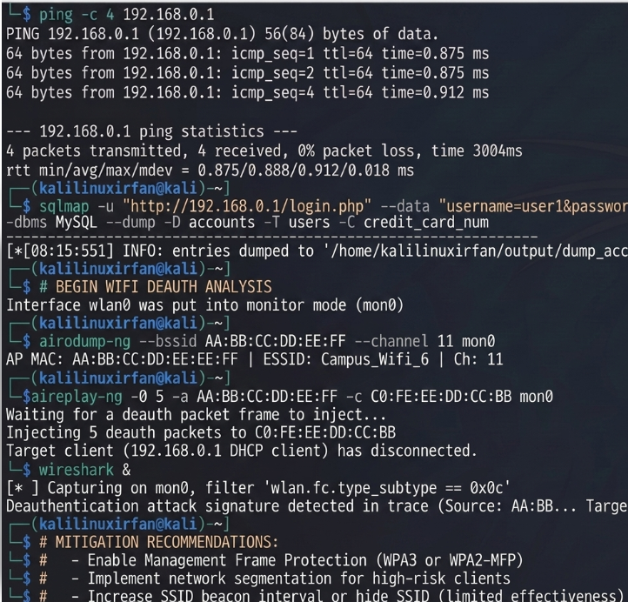

2. Attack Scenario
The 802.11 wireless standard includes management frames - including deauthentication and disassociation frames - that, in the absence of Protected Management Frames (802.11w), are not authenticated or encrypted. Any device within radio range can forge a deauthentication frame that appears to come from the access point (by spoofing the AP's MAC address) and send it to a target client, or to the broadcast address to hit every connected client at once. The client, trusting the frame at face value, disconnects immediately. An attacker running this continuously and at scale (targeting each observed AP/client pair repeatedly) produces the pattern reported here: connections that keep dropping and reconnecting throughout peak hours, since as soon as one round of clients reconnects, the attack simply repeats.

3. Attack Vectors / Vulnerabilities
- Unauthenticated 802.11 management frames (no 802.11w/PMF) - the core protocol weakness that allows a spoofed deauth frame to be trusted by clients.
- Open/large campus RF environment - many APs and a large radio footprint mean the attacker doesn't need physical access to any restricted area, just proximity to any campus AP.
- No wireless intrusion detection to flag abnormal deauth frame volume in real time, allowing the disruption to persist across peak hours before being investigated.
- Automated attack tooling (readily available, e.g. aireplay-ng or purpose-built deauther hardware/scripts) that lowers the skill needed to sustain the attack continuously.

4. Reconnaissance
To characterize the attack, reconnaissance focuses on identifying which APs and channels are affected and confirming the traffic pattern is deauth-driven rather than, say, congestion or a genuine hardware fault:
- airodump-ng to survey campus APs, channels, and client counts, and to look for anomalous, rapid client churn (clients repeatedly leaving and rejoining) concentrated on specific APs during the reported peak-hour windows.
- Wireshark with an 802.11 capture filter for management frames (wlan.fc.type_subtype == 0x0c for deauthentication) to confirm the presence and volume of deauth frames and identify the spoofed source addresses being used.

5. Scanning & Analysis
- Sustained airodump-ng monitoring per affected AP to quantify deauth frame rate over time and correlate spikes with the reported disruption windows.
- Wireshark statistical analysis (IO graphs filtered on deauth/disassoc frame types) to visualize attack intensity and distinguish a deliberate flood from ordinary background disassociation traffic.
- Triangulating signal strength across multiple monitoring points (where feasible) to narrow down the physical area the attack traffic is originating from.

6. Controlled Validation / Exploitation Methodology
To validate the mechanism and produce evidence for the report, the attack is simulated only in an isolated lab AP/client setup, never against the live production campus network:
- airmon-ng to place a test adapter into monitor mode on the lab AP's channel.
- aireplay-ng --deauth <count> -a <lab_AP_BSSID> -c <lab_client_MAC> mon0 to send a controlled burst of deauth frames at a lab test client and observe it disconnect, confirming the mechanism described above.
- Wireshark running concurrently to capture the forged frames and document the spoofed source address and frame rate, producing the same kind of evidence the campus IT team would look for in production logs.
- Repeating the test with 802.11w (Protected Management Frames) enabled on the lab AP to demonstrate that the same deauth flood no longer disconnects the client - directly validating the recommended mitigation.

7. Impact Analysis (CIA Triad)
- Availability - this is a pure availability attack: repeated forced disconnection during peak hours directly denies service to students, faculty, and staff relying on the network for coursework, research, and communication.
- Productivity - class activities, online assessments, and administrative work dependent on connectivity are disrupted, with cascading effects on anyone relying on the network at the affected time.
- Indirect confidentiality/integrity risk - repeated forced reconnections can also be used as a stepping stone (e.g. to push users toward a rogue AP as in an Evil Twin scenario), so a deauth campaign should be treated as a potential precursor to a more targeted attack, not only a nuisance.

8. Root Cause
The root cause is the unauthenticated nature of 802.11 management frames on the deployed APs (no Protected Management Frames), combined with the absence of wireless intrusion detection that would otherwise flag an abnormal volume of deauthentication traffic in real time and let campus IT respond during the attack rather than after repeated complaints.

9. Security Recommendations / Mitigation
- Enable 802.11w (Protected Management Frames) on all campus access points so deauthentication/disassociation frames are cryptographically authenticated and forged frames are rejected.
- Deploy a Wireless Intrusion Detection/Prevention System (WIDS/WIPS) tuned to alert on abnormal deauth/disassoc frame rates, enabling real-time detection instead of after-the-fact investigation.
- Move toward WPA3, which mandates Protected Management Frames and removes this class of attack as a viable option against compliant clients.
- Network configuration changes: increase AP density/capacity planning for peak-hour load so that legitimate congestion is not mistaken for attack activity, and segment critical services so a wireless disruption doesn't cascade into wired-service outages.
- Incident response runbook specifically for wireless DoS (RF triangulation procedure, escalation path) so campus IT can act quickly the next time abnormal deauth volume is flagged.
- Periodic wireless security assessments using the Aircrack-ng suite as part of routine operations, to catch configuration drift (e.g. PMF being disabled again) before it becomes exploitable.

10. Conclusion
Deauthentication-based denial of service exploits a genuine gap in the base 802.11 protocol rather than a misconfiguration unique to this campus, which is why the fix has to be protocol-level (Protected Management Frames / WPA3) rather than purely procedural. Paired with real-time wireless monitoring, this closes both the technical vulnerability and the detection gap that let the disruption persist across multiple peak-hour periods before it was investigated.

11. References
- OWASP Foundation, "OWASP Top 10:2021 - The Ten Most Critical Web Application Security Risks," owasp.org, 2021.
- NIST, "SP 800-115: Technical Guide to Information Security Testing and Assessment," National Institute of Standards and Technology, 2008.
- Offensive Security, "Kali Linux Official Documentation," kali.org/docs, accessed 2026.
- Aircrack-ng developers, "Aircrack-ng Documentation," aircrack-ng.org/documentation.html, accessed 2026.
- IEEE, "IEEE 802.11w-2009 Amendment: Protected Management Frames," ieee.org, accessed 2026.
- Wi-Fi Alliance, "WPA3 Specification and Security Overview," wi-fi.org, accessed 2026.

